**Create Node-RED Service**

|  |  |
| --- | --- |
| **Date** | **21-10-2022** |
| **Team ID** | **PNT2022TMID06420** |
| **Project Name** | **Project - IOT based safety gadget for child safety monitoring and notification** |
| **Maximum Marks** | **4 Marks** |
| **Submitted By** | **Ramya.N**  **Gokulapriya.M** |

Aim: To create a web application create a Node-RED service.

Steps followed:

* Navigated to the App creation page

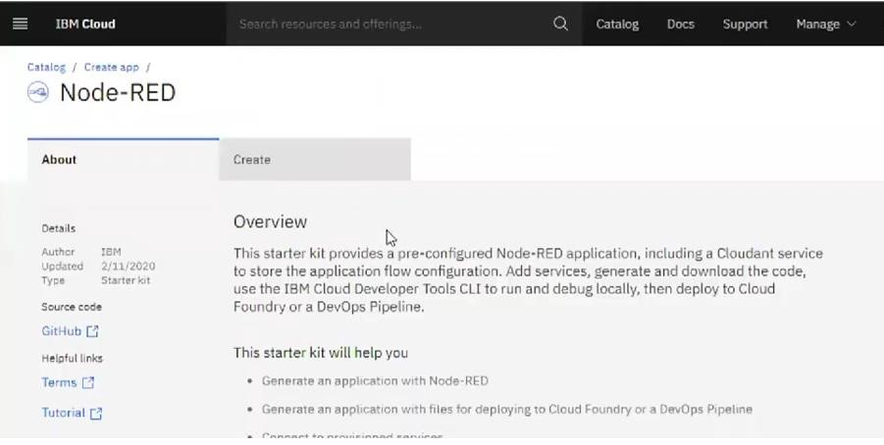

* Entered project details and clicked on create

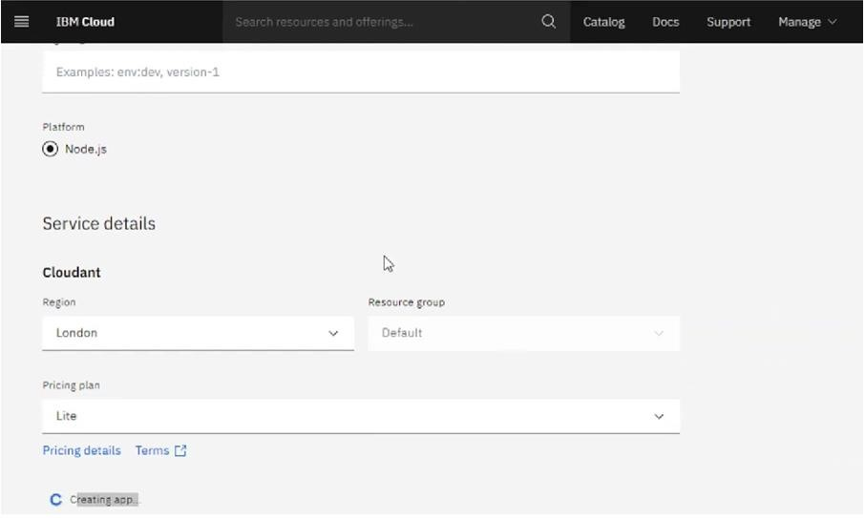

* Clicking on the “Deploy your App” Button

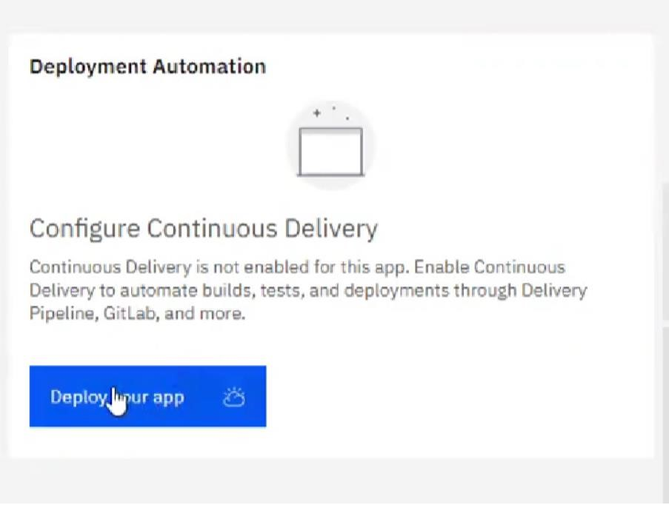

* Setting up the environment and deploying the app

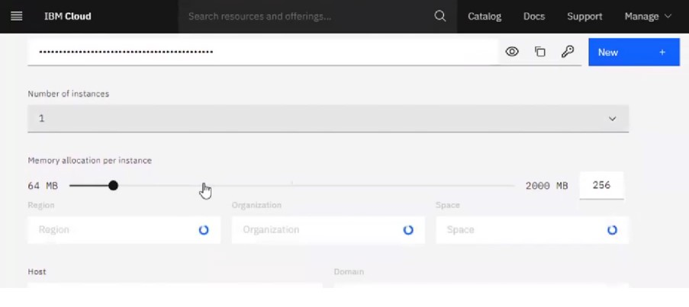

* Successfully deployed the app

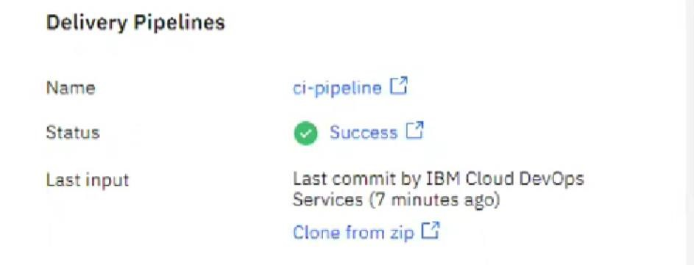

* Dragged and dropped components into the editor

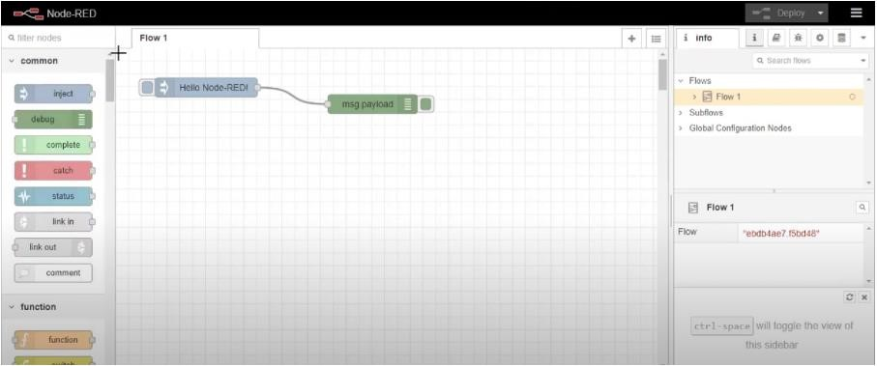

* Editing some values of the properties

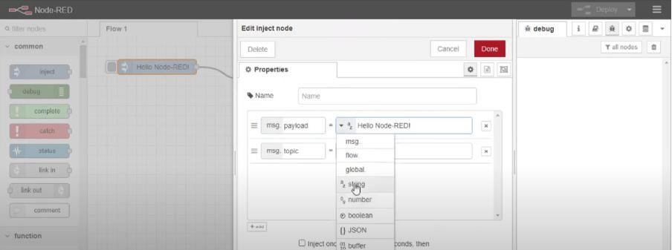

* Successfully deployed the app

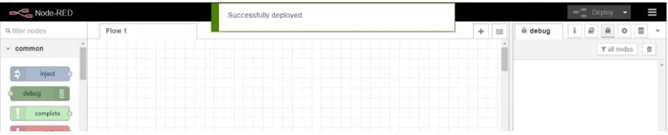

# Result: Successfully created a NodeRED service on IBM Cloud